Isai Mercado Oliveros

March 10, 2016

Lab 8 statistics

I am taking another statistics course, and I did not understand how covariance matrixes were calculated, but this lab helped me to understand how correlation matrixes are calculated. I remember that something about subtracting the mean was mentioned in order to calculate the covariance matrix, but I did not understand why. However, with this lab, I understood that data needs to be normalized because we do not want to calculate the cosine of a vector with an entry of 100000 to another vector with an entry of 0.00001 where the angle is going to be very small, and the computer is going to have round errors.

I also learned the different types of correlation:

1 is perfectly correlated

0 to 1 is positive correlated

0 is uncorrelated

0 to -1 is negative correlated

-1 is perfectly negative correlated

Correlation Matrix

1.0000 0.9951

0.9951 1.0000

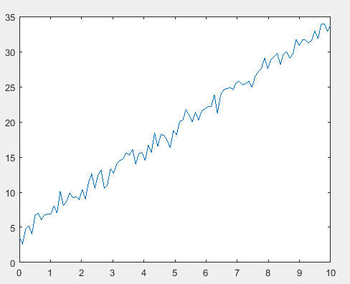

function correlation = compute_correlation(matrix_W)

dimensionX = 1;

dimensionY = 2;

rows = size(matrix_W,dimensionX);

cols = size(matrix_W,dimensionY) - 1;

matrix_ONES = ones(rows, cols);

% normalizing data because we do not want to deal with

% values of a million versus 0.000000001

matrix_X = matrix_W - (matrix_ONES * mean(matrix_W));

% This is the algorithm to compute the correlation matrix

% First calculate the standard deviation

matrix_Y = matrix_X ./ (matrix_ONES * sqrt(diag(matrix_X' * matrix_X)).');

% Then compute the covariance

matrix_COS = matrix_Y' * matrix_Y;

% The correlation matrix is a matrix that contains the cosine values

% of the angles between the vectors

correlation = matrix_COS;

plot(matrix_W(:,1), matrix_W(:,2))

end